*Title Title Title Title Title Title Title*

Firstname Lastname 1, Firstname Lastname 2 and Firstname Lastname 3

|  |
| --- |
| **Citation:** XXXXXXXXXXX .  **Copyright:** © This work is licensed under a Creative Commons Attribution 4.0 International License. |

1 Affiliation 1

2 Affiliation 2

2 Affiliation 3

Abstract

The abstract should be presented as a single paragraph not exceeding 250 words. For research articles, it must provide a concise and relevant overview of the study. Authors are encouraged to follow a structured approach without headings, incorporating the following elements: first, present the research question within a broad context and clearly state the aim of the work; second, summarize the principal methods or treatments used; third, highlight the main results of the study; and finally, state the key conclusions or interpretations drawn from the findings. The abstract should reflect the content of the article accurately, avoiding the inclusion of results not reported and supported in the main text, and refraining from overstating the significance of the conclusions.

Keywords: keyword 1; keyword 2; keyword 3 (max 6 keywords)

JEL classification: JEL code 1; JEL code 2; JEL code 3; (max 6)

Introduction

Authors should ensure that it positions the study within a broad and relevant context, making clear why the topic is significant. The introduction must define the research question, state the main objectives, and explain the study’s contribution to the field. It should include a concise review of the most relevant and recent literature, citing key publications that inform the research background. Where appropriate, authors should acknowledge and discuss conflicting viewpoints or unresolved issues to situate their work within ongoing scientific debates. The text should flow logically from general information to the specific focus of the study, leading naturally to the research question or hypothesis. Authors are encouraged to write in a style that is clear and accessible to readers from related disciplines, avoiding unnecessary jargon while maintaining scientific precision.

1. literature review

Authors should present a coherent and critical synthesis of previous studies, directly related to the research topic, while citing all sources in the format Author (date) or Author et al. (date) when there are more than two authors. The review should do more than list references; it must identify key themes, theoretical perspectives, methodological approaches, and significant findings, as well as point out existing gaps or inconsistencies in the literature. Authors are encouraged to organize the discussion either thematically or chronologically, ensuring a logical flow that progressively leads to the justification of the current study. Seminal works should be acknowledged alongside recent contributions, for example Smith (2015) or Johnson et al. (2020), to demonstrate awareness of the historical and current state of the field. When applicable, divergent findings or competing theories should be discussed objectively, indicating their implications for the research problem. The text should remain concise, avoiding unnecessary methodological details from previous works unless directly relevant to the argument.

1.1. Subsection

Text; Text; Text; Text; Text; Text; Text; Text; Text; Text; Text; Text; Text; Text; Text; Text; Text; Text; Text; Text; Text; Text; Text; Text; Text; Text; Text; Text; Text; Text; Text; Text; Text; Text; Text; Text; Text; Text; Text; Text; Text; Text; Text; Text; Text; Text; Text; Text; Text; Text; Text; Text;

1.1.1. Subsubsection

Text; Text; Text; Text; Text; Text; Text; Text; Text; Text; Text; Text; Text; Text; Text; Text; Text; Text; Text; Text; Text; Text; Text; Text; Text; Text; Text; Text; Text; Text; Text; Text; Text; Text; Text; Text; Text; Text; Text; Text; Text; Text; Text; Text; Text; Text; Text; Text; Text; Text; Text; Text;

2. Methods

The Methods section must present in detail all the elements necessary to enable the reproduction and further development of the published results. It should include a complete description of the data used, specifying their origin, characteristics, and any processing steps, as well as a clear presentation of the analytical methods employed. It is also essential to include an assessment of the robustness of the results, detailing the tests, procedures, or methodological variations used to verify the strength and reliability of the conclusions reached.

3.2. Figures and Schemes

All figures and tables should be cited in the main text as Figure 1, Table 1, etc.

**Figure 1.** This is a figure

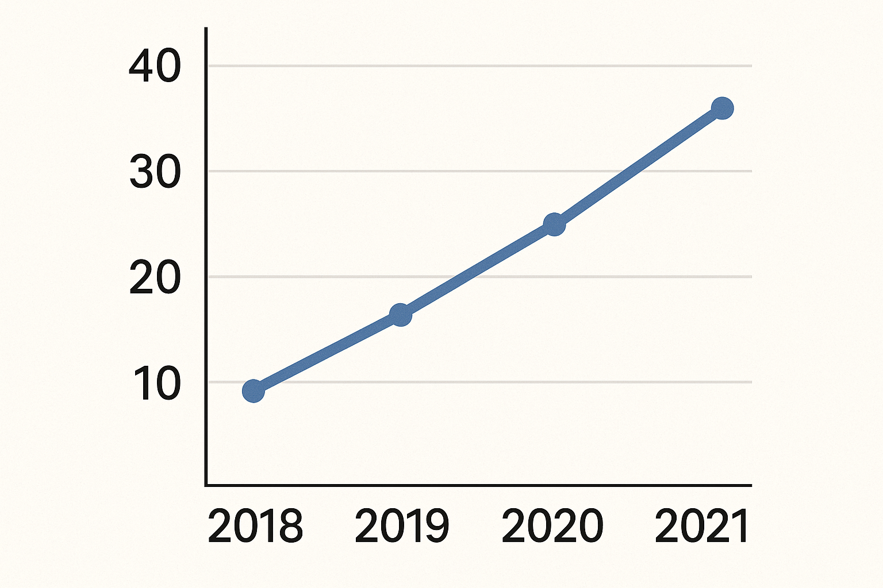

Text; Text; Text; Text; Text; Text; Text; Text; Text; Text; Text; Text; Text; Text; Text; Text; Text; Text; Text; Text; Text; Text; Text; Text; Text; Text; Text; Text; Text; Text; Text; Text; Text; Text; Text; Text; Text; Text; Text; Text; Text; Text; Text; Text; Text; Text; Text; Text; Text; Text; Text; Text;

**Table 1.** This is a table.

|  |  |  |
| --- | --- | --- |
| **Text** | **Text** | **Text** |
| Text | data | data |
| Text | data | data |

3. Results

The Results section must present the findings of the analysis clearly and systematically, highlighting the identified trends, relationships, or effects. It should be based on an accurate presentation of the data produced by the study, illustrated with tables, graphs, or figures to facilitate understanding. The results should be reported objectively, without interpretation or judgment, indicating the key values, indicators, or statistical measures essential for their comprehension. The aim is to provide a faithful and comprehensive account of the observations obtained, in accordance with the methods described in the previous section.

4. Discussion

The Discussion section should interpret and contextualize the findings by relating them to the research hypotheses and existing literature. It should explain the meaning of the observed trends, analyze any discrepancies from initial expectations, and identify potential factors that may account for these differences. This section should also highlight the theoretical and practical implications of the results, as well as any limitations linked to the context, data, or methodology used. Finally, it may propose avenues for future research, drawing on the lessons learned from the study and the new questions it raises.

Conclusions

The Conclusion should summarize the main findings of the study by briefly recalling the research objective, the approach followed, and the key results obtained. It should highlight the significance of these findings, both theoretically and practically, emphasizing their contribution to the advancement of knowledge and their relevance for policymakers or other stakeholders. The conclusion may also recall the identified limitations while suggesting directions for future research or improvements to current practices. It should provide a coherent and concise overview, enabling the reader to retain the essential elements of the work conducted.

References

1. Author, A. B., & Author, C. D. (Year). Title of the article. Abbreviated Journal Name, Volume(Issue), page range. APA
2. Author, A. B., & Author, C. D. (Year). Title of the article. Abbreviated Journal Name, Volume(Issue), page range. APA
3. Author, A. B., & Author, C. D. (Year). Title of the article. Abbreviated Journal Name, Volume(Issue), page range. APA
4. Author, A. B., & Author, C. D. (Year). Title of the article. Abbreviated Journal Name, Volume(Issue), page range. APA

**Note:** All statements, opinions, and data presented in the publications are the sole responsibility of the respective author(s) and contributor(s) and do not reflect the views of ***Journal of Supply Chain Management & Inventory***.